

**NIT6160 DATA WAREHOUSING AND MINING**

**Designing data warehouse for online brokerage company**

**Submitted by:**

Yasoda Rai

**Supervisor:**

Dr. Soheila Gheisari

**Table of Contents**

**List of figures:** 3

**1.Introduction:** 4

**2.Business Objective:** 4

**3.Data warehouse design:** 4

**4.Table structure:** 5

**5.Inserting data:** 7

**6.OLAP Queries:** 8

**7.Conclusion:** 9

**8.References:** 10

# **List of figures:**

**Figure 1: Fact table for online brokerage company** 5

**Figure 2:DIM_ACCOUNT table** 5

**Figure 3:DIM_CUSTOMER table** 5

**Figure 4:DIM_DATE table** 5

**Figure 5:DIM_SECURITY table** 6

**Figure 6:DIM_TRADETYPE table** 6

**Figure 7:FACTTABLE_TRADE table** 6

**Figure 8:Data of DIM_ACCOUNT** 6

**Figure 9:Data of DIM_CUSTOMER** 6

**Figure 10:Data of DIM_DATE** 7

**Figure 11:Data of DIM_SECURITY** 7

**Figure 12:Data of TRADETYPE** 7

**Figure 13:Data of FACTTABLE_TRADE** 7

# **1.Introduction:**

Advancement of the technology has led to create huge amount of data and those data may be useful for BI for decision making process. But to store large numbers of data for long period of time is difficult. However, data warehousing is one of the effective solutions for handling large numbers of data. Data warehousing is the method of developing and make use of data warehouse. Data warehouse collects and stored massive numbers of data from multiple sources. Within data warehouse, collected data are clean and integrated. Data warehouse can store the data for long period of time. Data warehouse support queries and organized reporting which can help business analytics in making or improving decision (Oracle.com, 2020; Tutorialspoint, 2020).

We are assigned to create data warehouse for the company named online brokerage company. They make their earning by charging commission to the customer while purchasing or selling the stocks. Trade fact table with dimension like Customer, Date, Account, Trade types and Security are designed using star schema. OLAP queries are used to analyse the data of online brokerage company.

# **2.Business Objective:**

Online brokerage company is the organization that brings in cash by charging commissions while clients are purchasing or selling the stocks. They use customer scoring techniques to analyse their business.

Data warehouse is very useful while decision making process. So, the company want to construct data warehouse. Performance indicators of company such as commission, number of trades, trade types, etc. can be used by business analyst while making decision. Hence, those indicators are collected to form a fact table while creating data warehouse.

# **3.Data warehouse design:**

Star schema is the method used to construct data warehouse. This schema shape looks like star as it has fact table in the centre with numbers of dimension tables around the fact table. Each dimension table have their own attribute as per the business need and fact table can reference dimension tables so it has some attributes of dimensions table.

Using star schema, fact table is created for online brokerage company. Dimension like customer, account, security, trade types and date are included. Data warehouse design for online brokerage company is shown below:

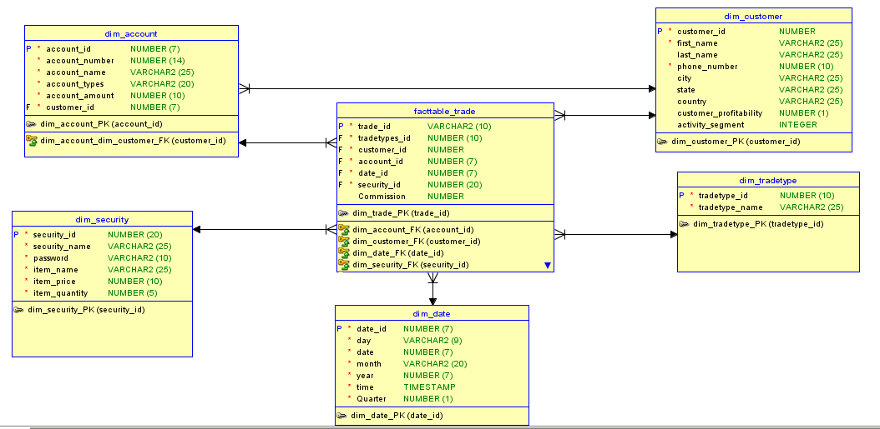

**Figure 1: Fact table for online brokerage company**

# **4.Table structure:**

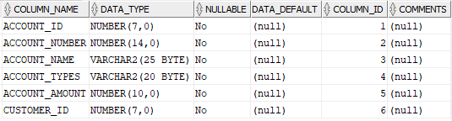

**Figure 2:DIM_ACCOUNT table**

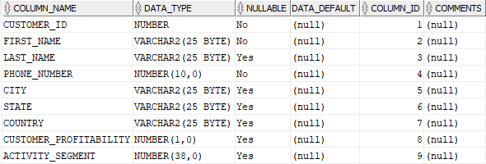

**Figure 3:DIM_CUSTOMER table**

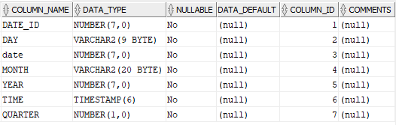

**Figure 4:DIM_DATE table**

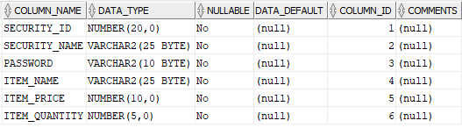

**Figure 5:DIM_SECURITY table**



**Figure 6:DIM_TRADETYPE table**

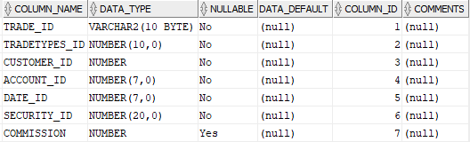

**Figure 7:FACTTABLE_TRADE table**

# **5.Inserting data:**

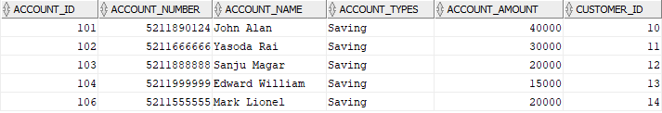

**Figure 8:Data of DIM_ACCOUNT**

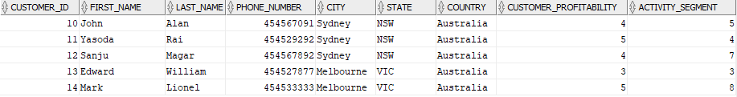

**Figure 9:Data of DIM_CUSTOMER**

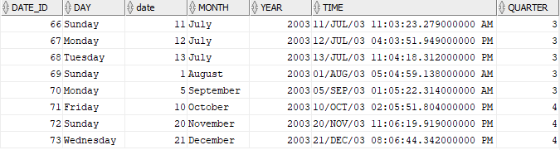

**Figure 10:Data of DIM_DATE**

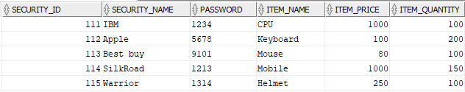

**Figure 11:Data of DIM_SECURITY**



**Figure 12:Data of TRADETYPE**

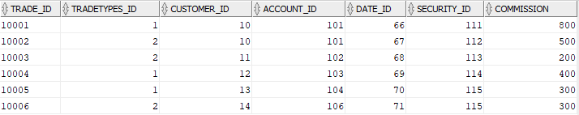

**Figure 13:Data of FACTTABLE_TRADE**

# **6.OLAP Queries:**

OLAP queries was used in Oracle SQL Developer to answer the following questions:

1. **How many trades were place in July by Customer “John Alan”?**

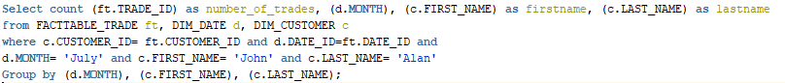

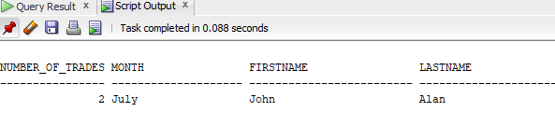

1. **What was the total commission earned in each quarter of 2003 on trades of IBM stock by customers with a profitability score of 4 or 5?**

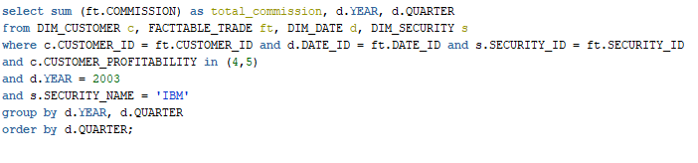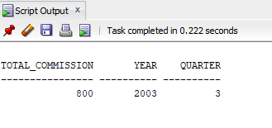

# **7.Conclusion:**

Data warehouse is playing great role in storing large numbers of data. So, this assignment involves the designing of data warehouse for online brokerage company. Dimension mentioned on the assignment were used to create fact table and had used OLAP query in Oracle SQL Developer to get the answer of the requirement of assignment.

# **8.References:**

En.wikipedia.org 2020, *Star Schema*, viewed 11 May 2020, <<https://en.wikipedia.org/wiki/Star_schema>>

Oracle.com 2020, *What Is A Data Warehouse?*, viewed 06 May 2020,< <https://www.oracle.com/database/what-is-a-data-warehouse/>>

Tutorialspoint, 2020, Data Warehousing-Concepts, tutorialspoint, viewed on 12/08/2019, <<https://www.tutorialspoint.com/dwh/dwh_data_warehousing.htm>>